Instructions for Preparing Camera-Ready Summaries for AM-FPD ’18

Taro Yamada, Koichi Suzuki¹ and Shigeru Tanaka²

University of AM-FPD, Graduate School of Engineering
3401, Hayano, Mobara, Chiba 297-0037, Japan
Phone: +81-475-23-1150 Fax: +81-475-25-7703 E-mail: secretariat@amfpd.jp
¹ABC Technology Co., Ltd., Research and Development Division
1-1 Am-Fpd, Kita-ku, Osaka 500-0000, Japan
²XYZ Electric Co., Ltd., Materials and Devices Development Center
2-2-2 Am-Fpd, Los Angeles, CA 91000, U.S.A.

This leaf presents instructions for preparing camera-ready summaries to be submitted to 2018 the 25th International Workshop on Active-Matrix Flatpanel Displays and Devices (AM-FPD ’18). A set of instructions is given in the style and format to be used by the authors. All papers, except the invited ones, to be presented at the Workshop will be mainly selected by Program Committee on the basis of submitted summaries.
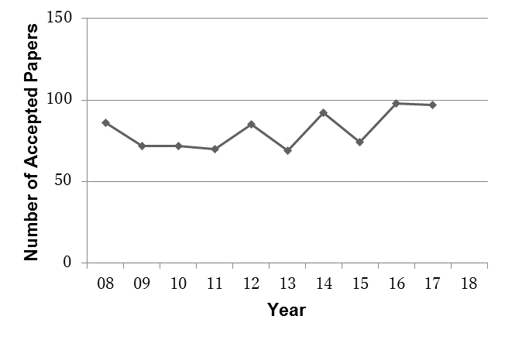

- Introduction
The summaries of accepted papers will be printed as they are and bound in the Proceedings for the Workshop. All the authors of invited papers, regular papers and late news papers are expected to carefully follow the instructions.

- General Instructions

Contents
Summaries should contain a concise description of the objective of the study, method of approach, significant results and conclusions.

Page Format
Submitted summaries must be camera-ready paper converted to PDF file and in 2 to 4 pages. The file size must be smaller than 3 MB. Please do not encode or compress the file. To avoid unexpected troubles in reviewing process, two-byte characters such as Japanese, Korean, Chinese, etc. fonts cannot be used for both figures and texts. Use A4 size or 8.5”×11” white bond paper. Typing area is 180 mm × 247 mm (7.1”×9.7”). Both text and figures must fit inside this area as indicated by the angles shown at the corners on this page. For A4 size paper, set top margin to 25 mm (1”), bottom margin to 25 mm (1”), left margin to 15 mm (0.59”) and right margin to 15 mm (0.59”). The column width is 86 mm (3.4”) with a 5 mm (0.2”) separation between the two columns. If you use 8.5”×11” paper, set top margin to 18 mm (0.7”), bottom margin to 15 mm (0.6”) and left and right margins to 18 mm (0.7”). Pages will be reproduced with the same size (100 %) on A4 size papers in the Proceedings.
Fig. 1. Number of accepted papers at AM-FPDs. This is an example of a Figure.

Text must be typed or printed clearly in English. At the center top of the first page, should be given the title of paper, author name(s), affiliation(s), address(es), and author’s contact phone number, fax number and e-mail address. Use capital letters for the initial letter of each word except articles, prepositions and conjunctions. Place a blank line between the title and author name(s), between author name(s) and the address (es), between the address (es) and the abstract and between the abstract and the main text.
The abstract and the main text should be typed single-spaced. The abstract spans the both columns, however, the main text should be written in the two columns. The sections should be numbered beginning with “1. Introduction”. Acknowledgments and References should not be numbered. Place a blank line between the sections. Subsection headings, if any, should not be numbered. Justify the column both at the right and the left. Don’t forget to check spellings.

Figures, Tables and Photographs
A summary may be furnished with your artwork such as Figures, Tables and Photographs. Large ones may span both columns. Photographs should be high contrast black and white originals. If you are using digital photographs, use a resolution of 600 dpi or less. Please provide the best quality of images possible. Place a blank line between the text and the tables, figures or photographs.

TableⅠ. Desirable Fonts.
Font size | Bold/Italic | Text
10 pt |  | Affiliation (s), Abstracts, Main text
10 pt | Bold | Headings (e.g., 1. Introduction)
12 pt |  | Author name (s)
14 pt | Bold | Title
10 pt | Italic | Subheadings (e.g., Page Format)
9 pt |  | References, Acknowledgments
 |  | Tables, Table captions, Figure captions
8 pt |  | Footnotes, Sub-and superscripts

Equations
Equations, if any, should appear on a separate line from the text with a blank space above and below. The equation number should appear in parentheses flush with the right margin as shown below for eq. (1). Punctuate equations with commas or periods when they appear as a part of a sentence like this,

$μ=A\text{exp}(−{{\text{eV}}_{b}}/{\text{kT}})\text{.}$ (1)
Fonts
Use proportional serif fonts such as Times-Fonts Family, Helvetica-Fonts Family, or Symbol Font. Font styles and sizes as specified in Table I are desirable.

References
List and number all the references, if any, at the end of the summary. The reference style in accordance with the one found in Japanese Journal of Applied Physics is recommended. When referring to them in the text, the reference number should be designated by closing parenthesis and superscript like this. ¹⁾

3. Submitting the Summary
The camera-ready regular paper for review in PDF file must be submitted via web site by March 22, 2018 and the 2-page camera-ready Late-News paper by May 7, 2018

4. Conclusions
A typical example of the page style and format for the camera-ready summaries for AM-FPD ’18 has been given.

Acknowledgments
We would like to express sincere thanks to all the contributors to the Workshop for their cooperation in the Workshop program.

References
1) A. Yamamoto and Y. Aoki: Dig. Tech. Papers 12th Int. Workshop Active-Matrix Flatpanel Displays and Devices, 2007, p. 127.
2) T. Nouda, K. Honda and N. Sato: Jpn. J. Appl. Phys. 15 (2005) 351.

Appendix
AM-FPD Secretariat
c/o Hitachi Urban Support, Ltd..
3401, Hayano, Mobara, Chiba 297-0037, Japan
Tel: +81-475-23-1150 Fax: +81-475-25-7703
E-mail: secretariat@amfpd.jp
Web Site: http://www.amfpd.jp

THE EXAMPLE OF MANUSCRIPT

1st PAGE 2nd~4th PAGES
 |  | Title
 |  | Author(s) name
 |  | Affiliation, Address, Tel, Fax, E-mail
 |  | Abstract (120 words max) |  |  |  |  |  |  |  |  |  |  |  | Table
 |  | Single  Spaced |  |  |  |  | Figure
 |  |  |  |  |  |  |  |  |  |  |  |  |  |  |  |  |  |  |  |  | Figure

